Sponsor form 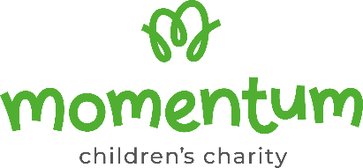

Event name________________________________________________ Event date_____________
Name ___________________________________________________________________________
Address ___________________________________________________Postcode ______________
By ticking the ‘Gift Aid?’ box, I confirm that I am a UK Income or Capital Gains taxpayer. I’ve read this statement and want Momentum Children’s Charity to reclaim tax on the donation below, given on the date shown. I understand that if I pay less Income Tax / or Capital Gains tax in the current tax year than the amount of Gift Aid claimed on all of my donations it is my responsibility to pay any difference. I understand the charity will reclaim 25p of tax on every £1 that I have given.

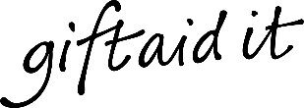

Sponsor’s full name | Sponsor’s home address | Sponsor’s postcode | Donation amount | Gift aid? | Date paid
Total
Date paid to charity
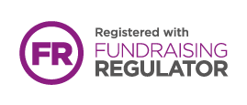
Please return collected sponsorship to:
Momentum Children’s Charity, 11a Creek Road, East Molesey, KT8 9BE
Registered charity number 1195373.

